Classification and Prediction

Supervised vs. Unsupervised Learning

  - Supervised learning (classification)
    - Supervision: The training data (observations, measurements, etc.) are accompanied by labels indicating the class of the observations
    - New data is classified based on the training set
  - Unsupervised learning (clustering)
    - The class labels of training data is unknown
    - Given a set of measurements, observations, etc. with the aim of establishing the existence of classes or clusters in the data

Classification vs. Prediction
- Classification
  - predicts categorical class labels (discrete or nominal)
  - classifies data (constructs a model) based on the training set and the values (class labels) in a classifying attribute and uses it in classifying new data
- Prediction
  - models continuous-valued functions, i.e., predicts unknown or missing values
- Typical applications
  - Credit/loan approval:
  - Medical diagnosis: if a tumor is cancerous or benign
  - Fraud detection: if a transaction is fraudulent
  - Web page categorization: which category it is

Classification—A Two-Step Process
- Model construction: describing a set of predetermined classes
  - Each tuple/sample is assumed to belong to a predefined class, as determined by the class label attribute
  - The set of tuples used for model construction is training set
  - The model is represented as classification rules, decision trees, or mathematical formulae
- Model usage: for classifying future or unknown objects
  - Estimate accuracy of the model
    - The known label of test sample is compared with the classified result from the model
    - Accuracy rate is the percentage of test set samples that are correctly classified by the model
    - Test set is independent of training set, otherwise over-fitting will occur
  - If the accuracy is acceptable, use the model to classify data tuples whose class labels are not known

Classifier (Model)
IF rank = ‘professor’ OR years > 6
THEN tenured = ‘yes’
NAME | RANK | YEARS | TENURED
Mike | Assistant Prof | 3 | no
Mary | Assistant Prof | 7 | yes
Bill | Professor | 2 | yes
Jim | Associate Prof | 7 | yes
Dave | Assistant Prof | 6 | no
Anne | Associate Prof | 3 | no

Process (1): Model Construction

Training Data
Classification Algorithms

Process (2): Using the Model in Prediction

Testing Data

Classifier

Unseen Data

(Jeff, Professor, 4)

Tenured?
NAME | RANK | YEARS | TENURED
Tom | Assistant Prof | 2 | no
Merlisa | Associate Prof | 7 | no
George | Professor | 5 | yes
Joseph | Assistant Prof | 7 | yes



Issues: Data Preparation
- Data cleaning
  - Preprocess data in order to reduce noise and handle missing values
- Relevance analysis (feature selection)
  - Remove the irrelevant or redundant attributes
- Data transformation
  - Generalize and/or normalize data

Issues: Evaluating Classification Methods

- Accuracy
  - classifier accuracy: predicting class label
  - predictor accuracy: guessing value of predicted attributes
- Speed
  - time to construct the model (training time)
  - time to use the model (classification/prediction time)
- Robustness: handling noise and missing values
- Scalability: efficiency in disk-resident databases
- Interpretability
  - understanding and insight provided by the model
- Other measures, e.g., goodness of rules, such as decision tree size or compactness of classification rules

Decision Tree Induction: Training Dataset

This follows an example of Quinlan’s ID3
age | income | student | credit_rating | buys_computer
<=30 | high | no | fair | no
<=30 | high | no | excellent | no
31…40 | high | no | fair | yes
>40 | medium | no | fair | yes
>40 | low | yes | fair | yes
>40 | low | yes | excellent | no
31…40 | low | yes | excellent | yes
<=30 | medium | no | fair | no
<=30 | low | yes | fair | yes
>40 | medium | yes | fair | yes
<=30 | medium | yes | excellent | yes
31…40 | medium | no | excellent | yes
31…40 | high | yes | fair | yes
>40 | medium | no | excellent | no

(Playing Tennis)

Output: A Decision Tree for “buys_computer”

<=30
31..40
age?

yes

no
overcast

>40

yes
student?

excellent

fair
credit rating?
no
no yes yes

Algorithm for Decision Tree Induction

  - Basic algorithm (a greedy algorithm)
    - Tree is constructed in a top-down recursive divide-and-conquer manner
    - At start, all the training examples are at the root
    - Attributes are categorical (if continuous-valued, they are discretized in advance)
    - Examples are partitioned recursively based on selected attributes
    - Test attributes are selected on the basis of a heuristic or statistical measure (e.g., information gain)
  - Conditions for stopping partitioning
    - All samples for a given node belong to the same class
    - There are no remaining attributes for further partitioning – majority voting is employed for classifying the leaf
    - There are no samples left

What Is Prediction?

- (Numerical) prediction is similar to classification
  - construct a model
  - use model to predict continuous or ordered value for a given input
- Prediction is different from classification
  - Classification refers to predict categorical class label
  - Prediction models continuous-valued functions
- Major method for prediction: regression
  - model the relationship between one or more independent or
predictor variables and a dependent or response variable
- Regression analysis
  - Linear and multiple regression
  - Non-linear regression
  - Other regression methods: generalized linear model, Poisson regression, log-linear models, regression trees

Linear Regression

- Linear regression: involves a response variable y and a single predictor variable x
y = w0 + w1 x
where w0 (y-intercept) and w1 (slope) are regression coefficients
- Method of least squares: estimates the best-fitting straight line
|D|
∑ ( xi − x )( yi − y )

w = i =1
w = y − w x

|D|
∑
1
( xi
i =1
− x )² 0 1

- Multiple linear regression: involves more than one predictor variable
  - Training data is of the form (X1, y1), (X2, y2),…, (X|D|, y|D|)
  - Ex. For 2-D data, we may have: y = w0 + w1 x1+ w2 x2
  - Solvable by extension of least square method or using SAS, S-Plus
  - Many nonlinear functions can be transformed into the above

Nonlinear Regression

Some nonlinear models can be modeled by a polynomial function
- A polynomial regression model can be transformed into linear regression model. For example,
y = w0 + w1 x + w2 x2 + w3 x3

convertible to linear with new variables: x2 = x2, x3= x3 y = w0 + w1 x + w2 x2 + w3 x3
- Other functions, such as power function, can also be transformed to linear model
- Some models are intractable nonlinear (e.g., sum of exponential terms)
  - possible to obtain least square estimates through extensive calculation on more complex formulae

Other Regression-Based Models

- Generalized linear model:
  - Foundation on which linear regression can be applied to modeling categorical response variables
  - Variance of y is a function of the mean value of y, not a constant
  - Logistic regression: models the prob. of some event occurring as a linear function of a set of predictor variables
  - Poisson regression: models the data that exhibit a Poisson distribution
- Log-linear models: (for categorical data)
  - Approximate discrete multidimensional prob. distributions
  - Also useful for data compression and smoothing
- Regression trees and model trees
  - Trees to predict continuous values rather than class labels

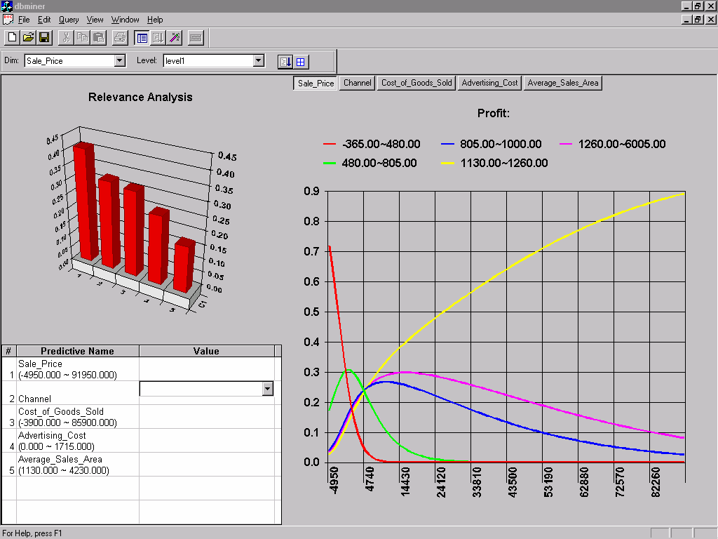
Prediction: Numerical Data

Prediction: Categorical Data

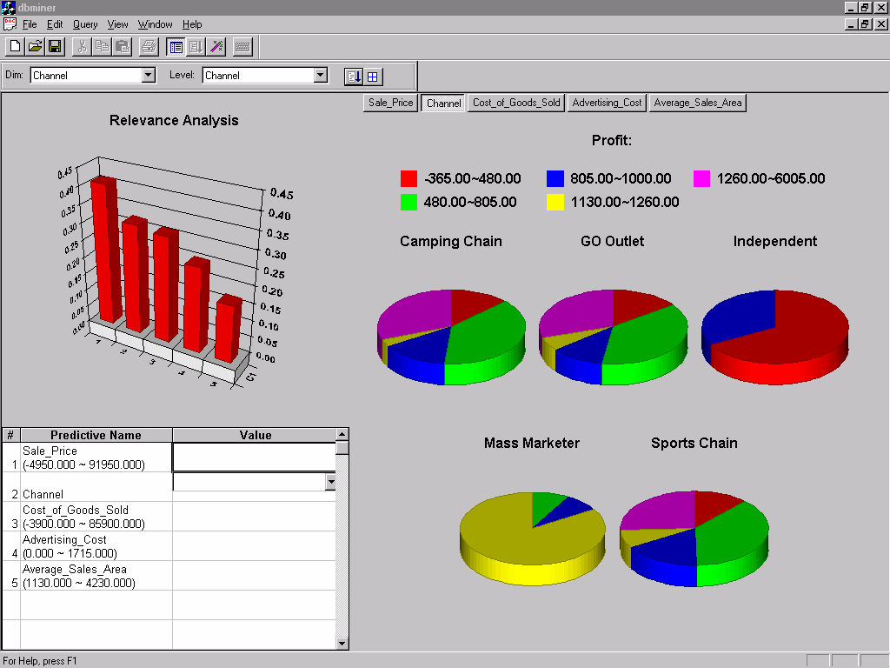
October 25, 2013 Data Mining: Concepts and Techniques 39

Classifier Accuracy Measures
Real class\Predicted class | C1 | ~C1
C1 | True positive | False negative
~C1 | False positive | True negative

Real class\Predicted class | buy_computer = yes | buy_computer = no | total | recognition(%)
buy_computer = yes | 6954 | 46 | 7000 | 99.34
buy_computer = no | 412 | 2588 | 3000 | 86.27
total | 7366 | 2634 | 10000 | 95.52
- Accuracy of a classifier M, acc(M): percentage of test set tuples that are correctly classified by the model M
  - Error rate (misclassification rate) of M = 1 – acc(M)
  - Given m classes, CM_{i,j}, an entry in a confusion matrix, indicates # of tuples in class i that are labeled by the classifier as class j
- Alternative accuracy measures (e.g., for cancer diagnosis) sensitivity = t-pos/pos /* true positive recognition rate */ specificity = t-neg/neg /* true negative recognition rate */ precision = t-pos/(t-pos + f-pos)
accuracy = sensitivity * pos/(pos + neg) + specificity * neg/(pos + neg)
  - This model can also be used for cost-benefit analysis

Predictor Error Measures

- Measure predictor accuracy: measure how far off the predicted value is from the actual known value
- Loss function: measures the error betw. yi and the predicted value yi’
  - Absolute error: | yi – yi’|
  - Squared error: (yi – yi’)2
- Test error (generalization error): the average loss over the test set
d
d

  - Mean absolute error:
∑| yi − yi '|
Mean squared error:
∑( yi − y ' )
2

i

i=1
d
i=1
_{d} d
i i

  - Relative absolute error: ∑
d

| y i −

y i ' |
Relative squared error:
∑( y − y ' )²

i = 1
d
i=1
d

∑ | y i − y |
∑( yi − y)

2

i = 1
The mean squared-error exaggerates the presence of outliers
i=1

Popularly use (square) root mean-square error, similarly, root relative squared error

Evaluating the Accuracy of a Classifier or Predictor (I)

- Holdout method
  - Given data is randomly partitioned into two independent sets
    - Training set (e.g., 2/3) for model construction
    - Test set (e.g., 1/3) for accuracy estimation
  - Random sampling: a variation of holdout
    - Repeat holdout k times, accuracy = avg. of the accuracies obtained
- Cross-validation (k-fold, where k = 10 is most popular)
  - Randomly partition the data into k mutually exclusive subsets, each approximately equal size
  - At i-th iteration, use Di as test set and others as training set
  - Leave-one-out: k folds where k = # of tuples, for small sized data
  - Stratified cross-validation: folds are stratified so that class dist. in each fold is approx. the same as that in the initial data

Model Selection: ROC Curves

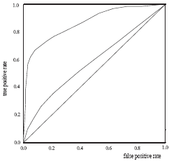
- ROC (Receiver Operating Characteristics) curves: for visual comparison of classification models
- Originated from signal detection theory
- Shows the trade-off between the true positive rate and the false positive rate
- The area under the ROC curve is a measure of the accuracy of the model
- Rank the test tuples in decreasing order: the one that is most likely to belong to the positive class appears at the top of the list
- The closer to the diagonal line (i.e., the closer the area is to 0.5), the less accurate is the model

- Vertical axis represents the true positive rate
- Horizontal axis rep. the false positive rate
- The plot also shows a diagonal line
- A model with perfect accuracy will have an area of 1.0

Bayesian Classification:

 Bayesian classifiers are statistical classifiers.
- They can predict class membership probabilities, such as the probability that a given tuple belongs to a particular class.
 Bayesian classification is based on Bayes’ theorem.

Bayes’ Theorem:

Let X be a data tuple. In Bayesian terms, X is considered ―evidence.‖and it is described by measurements made on a set of n attributes.

Let H be some hypothesis, such as that the data tuple X belongs to a specified class C.


For classification problems, we want to determine P(H|X), the probability that the hypothesis H holds given the ―evidence‖ or observed data tuple X.
P(H|X) is the posterior probability, or a posteriori probability, of H conditioned on X.

Bayes’ theorem is useful in that it provides a way of calculating the posterior probability,
P(H|X), from P(H), P(X|H), and P(X).

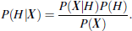

Naïve Bayesian Classification:

The naïve Bayesian classifier, or simple Bayesian classifier, works as follows:

- Let D be a training set of tuples and their associated class labels. As usual, each tuple is represented by an n-dimensional attribute vector, X = (x1, x2, …,xn), depicting n measurements made on the tuple from n attributes, respectively, A1, A2, …, An.
- Suppose that there are m classes, C1, C2, …, Cm. Given a tuple, X, the classifier will predict that X belongs to the class having the highest posterior probability, conditioned on X.
That is, the naïve Bayesian classifier predicts that tuple X belongs to the class Ci if and only if

Thus we maximize P(CijX). The classCifor which P(CijX) is maximized is called the maximum posteriori hypothesis. By Bayes’ theorem
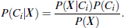
- As P(X) is constant for all classes, only P(X|Ci)P(Ci) need be maximized. If the class
prior probabilities are not known, then it is commonly assumed that the classes are equally likely, that is, P(C1) = P(C2) = …= P(Cm), and we would therefore maximize P(X|Ci).
Otherwise, we maximize P(X|Ci)P(Ci).

- Given data sets with many attributes, it would be extremely computationally expensiveto compute P(X|Ci). In order to reduce computation in evaluating P(X|Ci), the naive assumption of class conditional independence is made. This presumes that the values of the attributes areconditionally independent of one another, given the class label of the tuple. Thus,
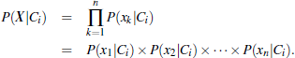

We can easily estimate the probabilities P(x1|Ci), P(x2|Ci), : : : , P(xn|Ci) fromthe trainingtuples. For eachattribute, we look at whether the attribute is categorical or continuous-valued. Forinstance, to compute P(X|Ci), we consider the following:
      - If A_{k}is categorical, then P(x_{k}|Ci) is the number of tuples of class Ciin D havingthe value
x_{k}for A_{k}, divided by |C_{i},_{D}| the number of tuples of class C_{i}in D.
      - If A_{k}is continuous-valued, then we need to do a bit more work, but the calculationis pretty straightforward.
A continuous-valued attribute is typically assumed tohave a Gaussian distribution with a mean μ and standard deviation , defined by
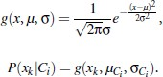

- In order to predict the class label of X, P(XjCi)P(Ci) is evaluated for each class Ci. The classifier predicts that the class label of tuple X is the class Ciif and only if

A Multilayer Feed-Forward Neural Network:


The backpropagation algorithm performs learning on a multilayer feed- forward neural network.
It iteratively learns a set of weights for prediction of the class label of tuples.

A multilayer feed-forward neural network consists of an input layer, one or more hiddenlayers, and an output layer.

Example:
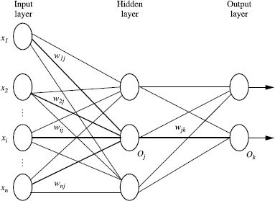



The inputs to the network correspond to the attributes measured for each training tuple. The inputs are fed simultaneously into the units making up the input layer. These inputs pass through the input layer and are then weighted and fed simultaneously to a second layer known as a hidden layer.

The outputs of the hidden layer units can be input to another hidden layer, and so on. The number of hidden layers is arbitrary.
The weighted outputs of the last hidden layer are input to units making up the output layer, which emits the network’s prediction for given tuples.

Classification by Backpropagation:

Backpropagation is a neural network learning algorithm.


A neural network is a set of connected input/output units in which each connection has a weight associated with it.

During the learning phase, the network learns by adjusting the weights so as to be able to predict the correct class label of the input tuples.
Neural network learning is also referred to as connectionist learning due to the connections between units.


Neural networks involve long training times and are therefore more suitable for applications where this is feasible.
 Backpropagation learns by iteratively processing a data set of training tuples, comparing the network’s prediction for each tuple with the actual known target value.
 The target value may be the known class label of the training tuple (for classification problems) or a continuous value (for prediction).
- For each training tuple, the weights are modified so as to minimize the mean squared error between the network’s prediction and the actual target value.

- These modifications are made in the ―backwards‖ direction, that is, from the output layer, through each hidden layer down to the first hidden layer hence the name is backpropagation.
 Although it is not guaranteed, in general the weights will eventually converge, and the learning process stops.

Advantages:
 It include their high tolerance of noisy data as well as their ability to classify patterns on which they have not been trained.
 They can be used when you may have little knowledge of the relationships between attributes and classes.
 They are well-suited for continuous-valued inputs and outputs, unlike most decision tree algorithms.
 They have been successful on a wide array of real-world data, including handwritten character recognition, pathology and laboratory medicine, and training a computer to pronounce English text.
 Neural network algorithms are inherently parallel; parallelization techniques can be used to speed up the computation process.

Process:

Initialize the weights:

The weights in the network are initialized to small random numbers
ranging from-1.0 to 1.0, or -0.5 to 0.5. Each unit has a bias associated with it. The biases are similarly initialized to small random numbers.

Each training tuple, X, is processed by the following steps.

Propagate the inputs forward:

First, the training tuple is fed to the input layer of the network. The inputs pass through the input units, unchanged. That is, for an input unit j, its output, Oj, is equal to its input value, Ij. Next, the net input and output of each unit in the hidden and output layers are computed. The net input to a unit in the hidden or output layers is computed as a linear combination of its inputs.
Each such unit has a number of inputs to it that are, in fact, the outputs of the units connected to it in the previous layer. Each connection has a weight. To compute the net input to the unit, each input connected to the unit is multiplied by its corresponding weight, and this is summed.

Where w_{i,j} is the weight of the connection from unit i in the previous layer to unit j; O_{i} is the output of unit i from the previous layer
_{Ɵj} is the bias of the unit & it acts as a threshold in that it serves to vary the activity of the unit.

Each unit in the hidden and output layers takes its net input and then applies an activation function to it.
